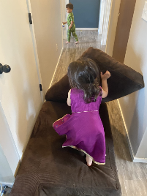
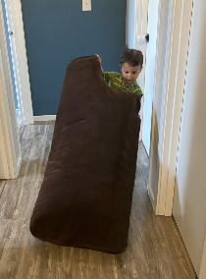
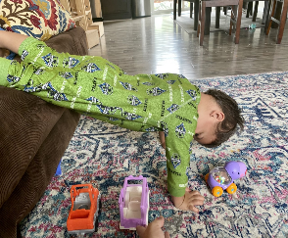
Fun with Pillows
You can do a lot of core exercises for kids with pillows you have a couch with big cushions set them up on the floor and ask your child to turn them over as many times in a row as they can. You can also have them drag the cushions o or large pillows from one end of t the living room to the other and p place a few toys on top along t the way to see how long they can g go without dropping them.
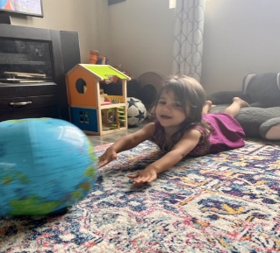
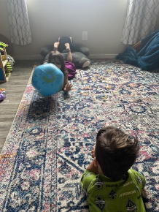
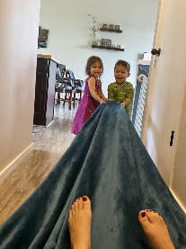
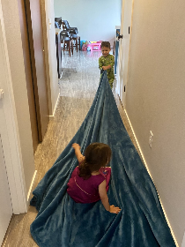
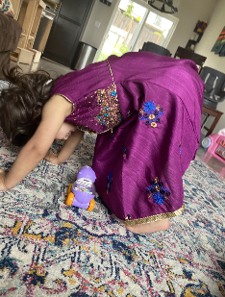
Body Bridges
Have you child place their feet up on the couch with their hands on the floor to make a bridge. See if they can hold it long enough to roll a ball, toy car, or favorite stuffed animal under the bridge. You can modify this activity by placing hands and feet on the ground and k Keeping your body off the g ground in a dog position or l laying on their back with f feet on the floor and lifting t their hips off the floor.

Supermans
Have your child lie on their tummy and the lift their arms and legs off the ground and see how long they can hold it for. You can also play superman catch by rolling a ball back a and forth with a partner m making sure to keep their a arms and elbows off the g ground.
Blanket Pull
Have your child pull something heavy on a blanket from one end of a room or hallway to the other. They could pull a sibling, a weighted toy, a basket of laundry or a small collection of favorite books. Pulling on smooth t pile or wood floors is going to be e easier than pulling on carpet so a adjust the surface for your child’s n needs.

